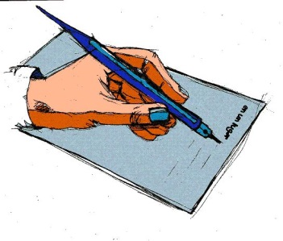
A description puts something in words, like a portrait puts a person in paint. The lawnmower you came home with did not quite fit the description of the dishwasher you went shopping for.
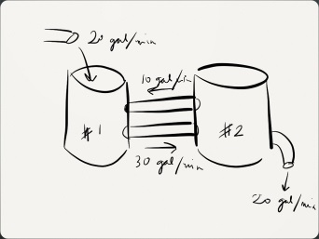

The root for description is the Latin word descriptio, meaning “to write down.” The “script” in description tells you that a good description makes what it describes come to life, like a script for a movie.

For example: Your description of that fudge almond swirl ice cream was so good I could taste it! Unfortunately, I'm allergic to nuts.

