# M/WBE Documents

**M/WBE Goal Calculation Worksheet**

**(This form should reflect the current year’s budgeted costs)**

**RFP # and Title: Applicant Name:**

The M/WBE participation for this grant is 30% of each applicant’s total discretionary non- personal service budget over the entire term of the grant. Discretionary non-personal service budget is defined as the total budget, excluding the sum of funds budgeted for direct personal services (i.e., professional and support staff salaries) and fringe benefits, as well as rent, lease, utilities, and indirect costs, if these are allowable expenditures.

# Please complete the following table to determine the dollar amount of the M/WBE goal for this project year.

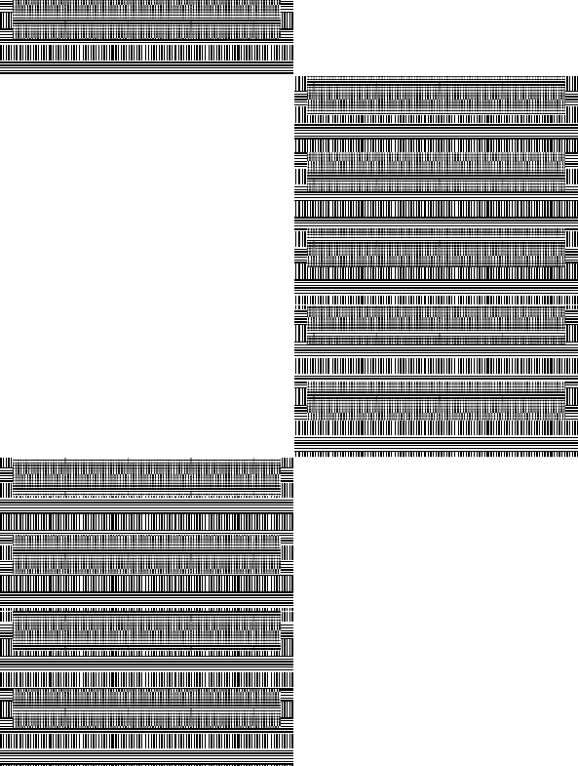

|  |  |  |  |
| --- | --- | --- | --- |
|  | **Budget Category** | **Amount budgeted for items excluded from M/WBE calculation** | **Totals (Current FS-10)** |
| **1.** | **Total Budget** |  |  |
|  |
| **2.** | **Professional Salaries** |  |  |
| **3.** | **Support Staff Salaries** |  |  |
| **4.** | **Fringe Benefits** |  |  |
| **5.** | **Indirect Costs** |  |  |
| **6.** | **Rent/Lease/Utilities\*** |  |  |
|  |
| **7.** | **Sum of lines 2, 3 ,4 ,5,**  **and 6** |  |  |
| **8.** | **Line 1 minus Line 7** |  |  |
| **9.** | **M/WBE Goal percentage (30%)** |  | **0.30** |
| **10.** | **Line 8 multiplied by Line 9**  **=MWBE goal amount** |  |  |

*If not included in #5

NYSED Internal Use Only (please check one):

* For Original/Annual Submission ☐ For Amendment Submission #